# Design Documentation

## Concept of operations

The purpose of the application is to calculate dimensions of a room based on measurements provided by the user.

In its current state, the application receives the height and length of each wall as string input through textboxes. The user can also switch between Metres and Feet as input and output measurement.

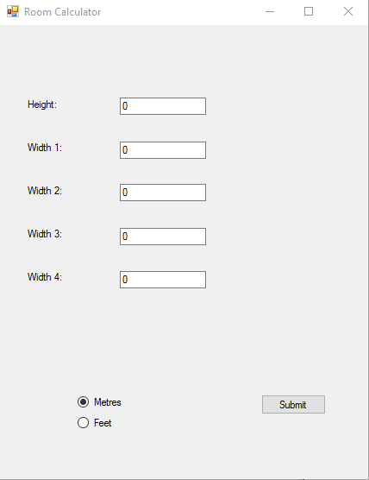The results of the calculations are displayed in labels at the bottom of the user interface.

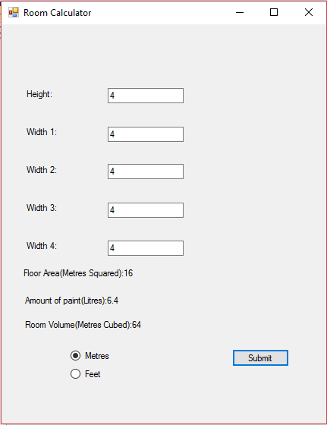

## Test Log

|  |  |  |  |  |  |
| --- | --- | --- | --- | --- | --- |
| Test Number | Test | Expected Result | Actual Result | Pass or Fail | Comments |
| 1 | Leaving a textbox blank and submitting | The validation method should show an error message and not calculate the measurements | The validation method shows the error messages and does not calculate measurements | Pass |  |
| 2 | Typing “0” into a textbox and submitting | The validation method should show an error message and not calculate the measurements. | The validation method shows the error message and does not calculate the measurements. | Pass |  |
| 3 | Typing “abc” into a textbox and submitting | The validation method should show an error message and not calculate the measurements. | The application attempts to calculate the measurements but crashes. | Fail | Fixed the issue by adding a check to the validation method to ensure that the user only enters numbers. |
| 4 | Entering ‘8’, ‘11’, ‘12’, ‘2’, ‘2’ into each textbox respectively and submitting | The measurements should be calculated and displayed. | The volume and Floor area are displayed as “NaN” due to the resulting decimal being too large. | Fail | Fixed the issue by adding that the results be displayed as decimals to only two places. |
| 5 | Typing “1 Metre” into a textbox and submitting | The validation method should show an error message and not calculate the measurements. | The validation method shows the error message and does not calculate the measurements. | Pass |  |

## Known Issues and Improvement Potential

Currently the app can only calculate the dimensions of cuboids, the height of which must remain constant at all points of the room. This is due to the complex mathematics required to calculate the dimensions of other room shapes.

Additionally, the application can only accept integer values due to the way in which C# handles decimal values.

When selecting feet as input, the amount of paint will still be displayed in litres instead of pints.